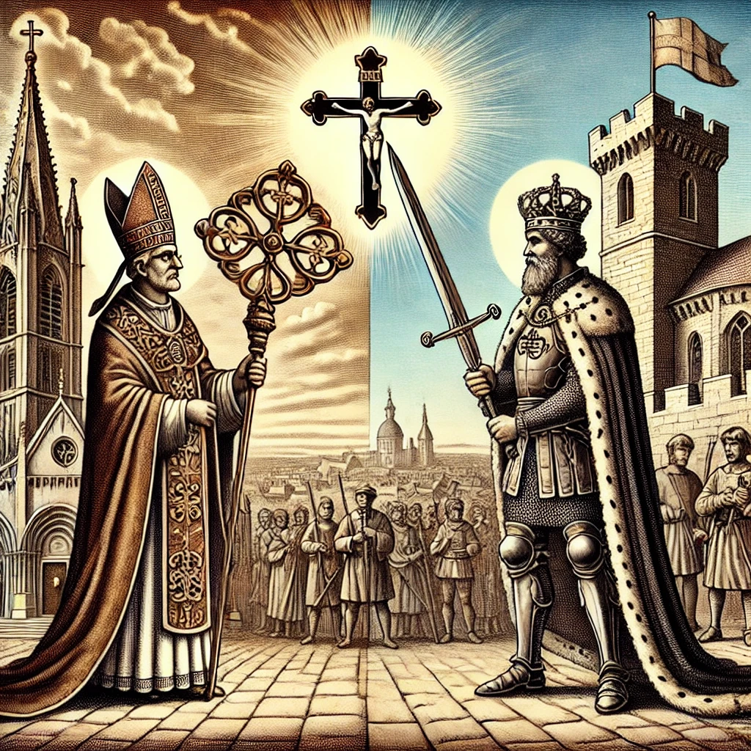Mound Free U

6 October 2024

# The 5th Commandment

Christian Responsibility During Elections[1]

## Sovereignty

### Absolute Sovereignty of God

Read Ps 2:1-4, Rom 13:1-4, Col 1:16-20. Are you worried about the potential outcome of our upcoming election? Does God have interest in the outcome of our upcoming election? Does He have the ability to influence it? What do your concerns reflect about your faith in God’s sovereignty?

### Delegated Sovereignty of Men

#### Power of the Sword (Government)

Read Gen 4:9-15, 23-24, 9:1-7, Rom 13:1-7. When was the power of the sword (coersion) delegated to man? Read Gen 9:11-16. Who exercised the power of the sword prior to that? What is the impact of injustice on the creation mandate (Gen 1:22, 28, 8:17, 9:1, 7)? From what does the power of the sword remove you? Does the delegated nature of the authority of government imply constraints? If so, what are the limits on the power of government? Read Gen 12:1-3. Why do you think Genesis 9 occurs before Gen 12?

#### Power of the Keys (Church)

Read Matt 16:18-19, 18:15-20, 28:18-20. How does the church affirm who does and does not belong in the body of Christ? What is to be bound or loosed with these keys? For what does the Church strive? (Matt 5:43-48, Matt 19:21, John 17:23, Rom 12:2) Is the power of coersion given to the church or is this a declarative power? What are the consequences of loosing? (1 Cor 5:4-5)

#### Separation of Church and State

Emperor Theodosius I declared Christianity to be the religion of the state in 380 AD, and conversion by force was instituted throughout much of the middle ages. Read Acts 1:6-8. Contrast the concern of the apostles with the mission Jesus sets before them. Acts 4:14-20, 11:26, 2 Cor 6:14-18. What role did coersion play in the mission that the apostles were given?

#### Christian Nationalism

The following is from the EFCA’s Affirmations and Denials:

We are not “Christian Nationalists” who believe the federal government should declare the United States a Christian nation or who believe that Americans are “God’s chosen people,” but we do believe that a patriotic love of one’s nation is appropriate and that Christians should be good citizens who may freely advocate for God-honoring public policies.

* We do not believe that political means can establish the kingdom of God, but we do believe that God has appointed governing authorities to do good and that, for citizens in Christ's kingdom, King Jesus’ rule and reign transcends all other citizenships and partisan ideologies and transforms how we live in the world.[2]

Read 2 Chron 7:12-16, Isa 43:1-7, Acts 4:18, Acts 15:14-18, What is the church? What are the implications of being called by the name of Christ? Read Jer 7:8-15, 30-34. What are the consequences of bringing shame to that name? What are the implications of identifying a secular organization or individual as “Christian”? How can we engage with the world without being consumed by it? (Matt 5:13)

## Christian Engagement with Government

### Kingdom of God

What is the mission of the Church? (Ps 96:10, Mat 28:19). How are we to live in light of this citizenship? (Phil 3:12-21, Matt 10:16, James 1:5, 3:17) How should this mission guide our participation in politics?

### Kingdom of Man

Are we citizens of an earthly kingdom? (See Acts 16:37-38, 22:25-29). What are the implications of serving two masters? (Matt 6:24, Deut 17:15, Isa 31:1) What is our responsibility to civilian government? (See 2 Cor 5:20, 1 Pet 2:11-17) How do our actions reflect on the integrity and credibility of our witness? Read Acts 19:23-27. Do the actions and beliefs of Christians have an impact on the world? Is that the goal?

### Justice

Read Matt 22:15-22. Justice requires that judgment be rendered according to a standard. What is the standard? Read Gen 1:26-27, 9:6, Rev 19:11-16. What are the implications of being made in the image of God?

1. This material is based on a presentation by Jonathan Leeman at the EFCA 2024 Theology Preconference. His lectures can be found at <https://helps.efca.org/bundles/2024-efca-theology-preconference-resources> (accessed 4 Oct 2024).
2. EFCA. “Where We Stand in the EFCA: Denials and Affirmations,” <https://www.efca.org/where-we-stand-in-the-efca-denials-and-affirmations> (accessed 5 Oct 2024).